CSC 120 Lab 01

This is an introductory lab. **The purpose of this lab is to understand your background and to provide guidance on how to submit assignments using Blackboard.** Questions will require you to provide screenshots as proof of your understanding. Make sure you attempt everything as there are points for attempting. Good luck!

**Motivation (**25 points)

Please provide your motivation for taking this class.

I am trying to figure out what I want to major in at my public university I am currently at and hopefully this class will help me figure that out. Not sure whether I want to major in business or more of a stem field.

**Background** (25 points)

Please provide a short summary of your computer science background. You can answer ‘None’ if you do not have any background.

* Do you have any experience with programming? If yes, which language?

I do! Just a little bit with HTML, Java and SQL. I do not have any experience with Python though.

* Have you ever used Python? If so, in what capacity?

None

* Do you have any experience with digital logic and binary?

None

* Do you have any experience with algorithm design?

None

**Resources (**25 points)

* Do you have access to a laptop and internet?

Yes, I do.

* Are you able to find the lectures and assignments on Blackboard? Please provide a screenshot.

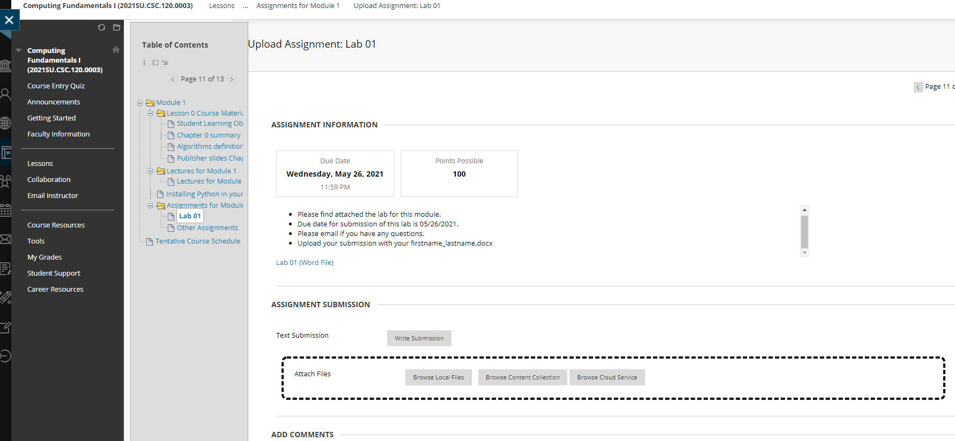

* How would you join office hours? You can find the answer in Faculty Information.

You can use Microsoft Teams to contact Mr. Man-Chi Leung or use email for any questions.

* Do you know where to read the announcements on Blackboard? Please provide a screenshot.

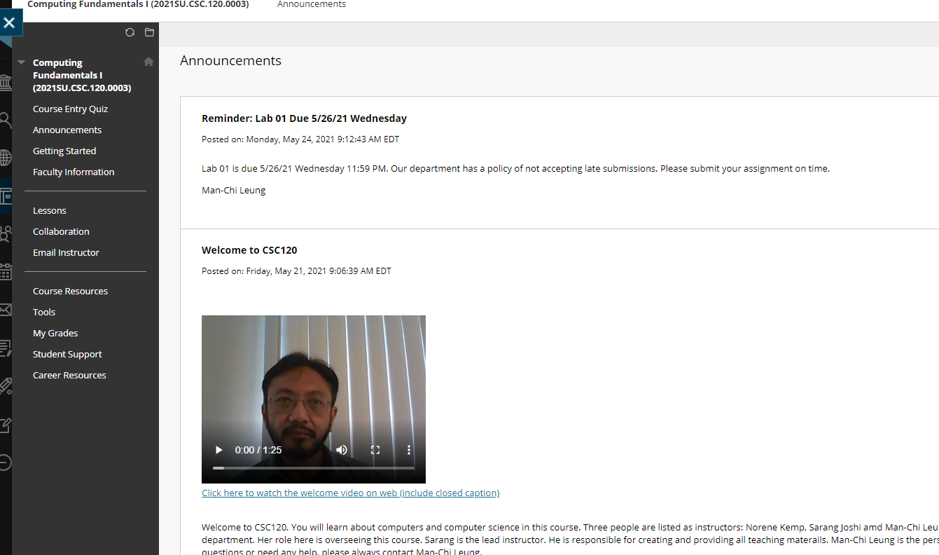

* Do you know where to find the course syllabus? Please provide a screenshot

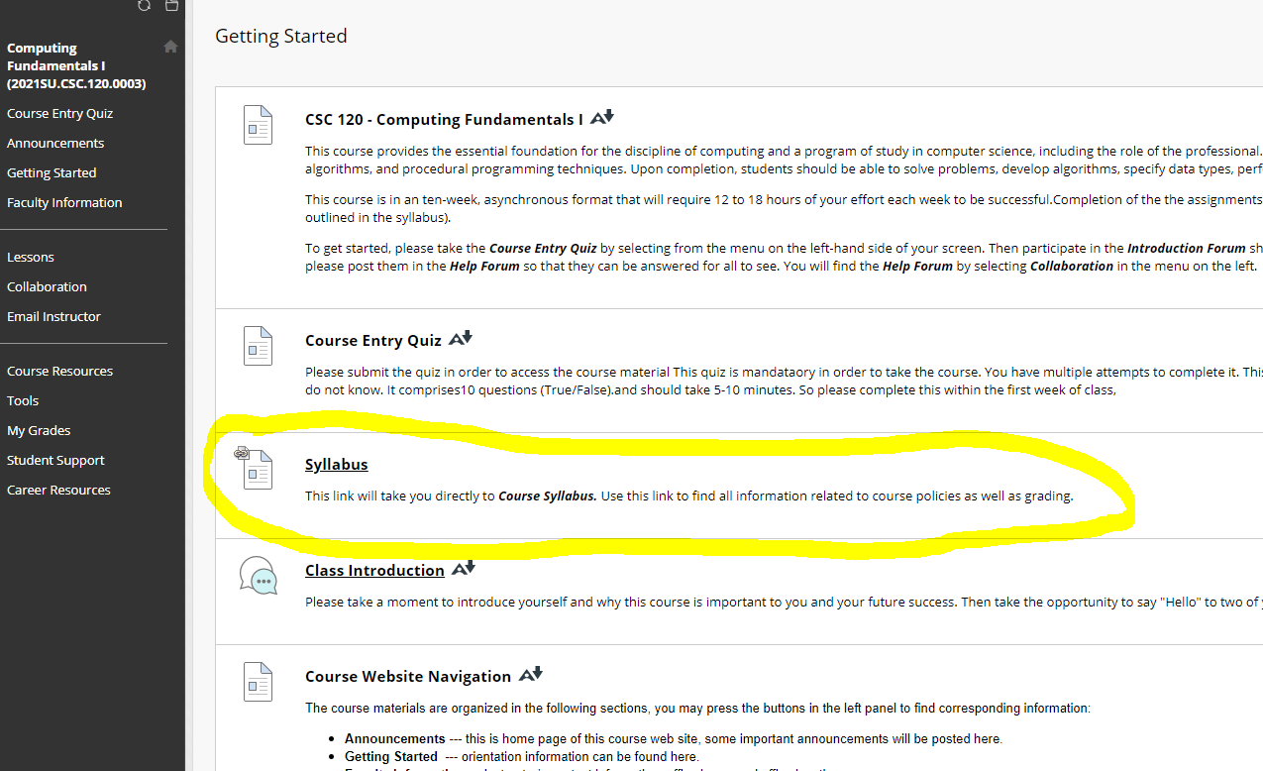

**Google Colab (**30 points)

Please create an account and a new notebook on Google Colab and provide a url to the Notebook. You can find a video about Google Colab in “Lectures for Module 1”.

<https://colab.research.google.com/drive/1Uxs3XBc18I6MMZdhT6-VTXRaMawcDMMB?usp=sharing>

For example, here is a sample url to a Notebook I have created for this class. *https://colab.research.google.com/drive/1q8SCxYjgFxzZNcrdR1AMsG2Iys6rcD7O?usp=sharing*

**Instructions: Upload the file with your firstname_lastname.docx to Blackboard for credit**